TITLE OF ABSTRACT

First Author¹, Second Author², Third Author³, etc.
¹ Affiliation of first author,
² Affiliation of second author.
³ Affiliation of third author.

Topic(s): Specify topic(s) from the following list (particles, drops/bubbles, swimmers, immiscible stratified fluids, miscible stratified fluids, other).

Key words: A few key words of your choice.

Abstract:
The abstract should typically be 1 page long, possibly with a figure. The underlined author name is that of the person who is going to present the work at the conference.

Please upload the generated pdf on the abstract submission field in the New submission link, and provide a zipped version of the source text and figures as supplementary data (to help us in compiling a book of abstract).

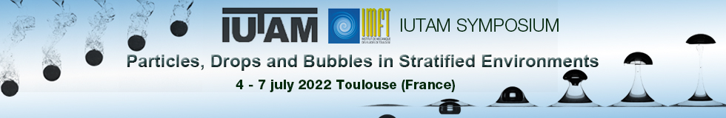
Figure 1: Caption (our website banner actually).

We have made use of some work done at IMFT [1,2] to produce a website banner (Fig. 1).

References

- Bonhomme R, Magnaudet J, Duval F, Piar B. Inertial dynamics of air bubbles crossing a horizontal fluid–fluid interface. J. Fluid Mech. 707, 405-443 (2012).

- Pierson JL, Magnaudet J. Inertial settling of a sphere through an interface. Part 1: From sphere flotation to wake fragmentation. J. Fluid Mech. 835, 762–807 (2018).

